**ERD RESTAURANT LSP**

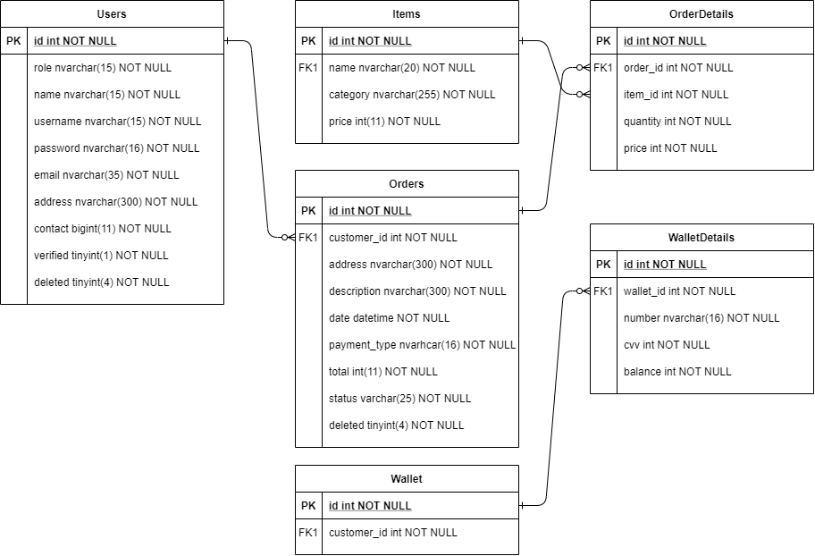

**FLOWCHART RESTAURANT LSP**

